Chapter 1. Introduction

1.1 Research Motivation

With the rapid development of Internet of Things (IOT) [1], all devices are gradually able to communicate via the Internet. In order to get more information, humans use the technology of wireless sensor network (WSN) extensively. WSN technology can be used in various applications because it has many advantages, such as lower cost, scalability, reliability, accuracy, flexibility, and ease of deployment. As wireless sensor nodes become smarter, smaller and cheaper, billions of wireless sensor nodes are deployed in many applications scenario. For example, sensor nodes can be used to detect, locate or track enemy movements. In addition, it can sense and detect the environment to predict disasters in advance. Moreover, sensor nodes can help monitor a patient's health [2]. In the security, sensors can provide vigilant surveillance and increase alertness to potential terrorist attacks [3]. In the future, wireless sensor networks will eventually realize automatic monitoring of forest fires, avalanches, hurricanes, transportation, hospitals, etc. The wide range of potential applications for wireless sensor networks has made WSN as a fast-growing multi-purpose network [4].

Although the WSN allows users access information more convenient, there are some inherent problems. WSN is composed of wireless sensor nodes and relay nodes. Each sensor node will sense various kinds of information then transfer them to relay nodes. All of actions will consume energy, but the energy of sensors is limited by battery capacity. When the energy of sensor node is exhausted, they may cause obstacles in the operation of the WSN. With the development of wireless charging technology, Wireless Rechargeable Sensor Network (WRSN) [5-7] are proposed to solve the network lifetime problem. WRSN is composed of charging stations, sensor nodes and relay nodes where 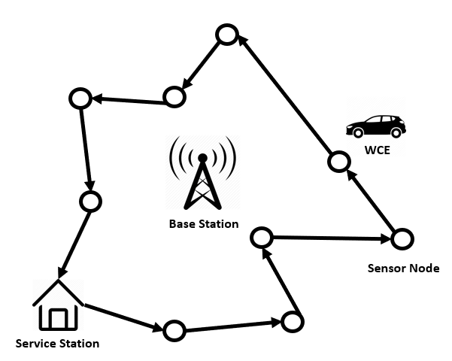the charging stations are the power resource for other components.

Figure 1. Typical example of outdoor environment

The environment of WRSN can be broadly divided into two categories: indoor and outdoor. A typical example of outdoor environment is depicted in Figure 1. From the Figure 1 we can find that a vehicle carries a wireless charging equipment (WCE) and travels along with the prior path planning to charge the power of sensor nodes. Because of the distance of the vehicle’s movement and the lifecycle of the sensor nodes are limited, the planning of the vehicle’s motion path is important in this area of research. It is important to ensure that sensor nodes do not fail to deplete the WSN due to energy depletion, and charge as many and further sensor nodes as possible under the limited energy of WCE. In order to allow the WCE to travel further distance, Zhang *et al.* [8] proposed a Push-Wait mechanism where WCEs are allowed to intentionally transfer energy between themselves. However, the algorithm needs too many WCE. Liu *et al.* [9] proposed a Push-Shuttle-Back mechanism to enhance Push-Wait. With the help of shuttle, which is WCE can go back to base station halfway to replenish energy, it can reduce the energy loss of the movement process and the charging process between WCE. And utilized the least number of WCE. In terms of path planning, Lyu *et al.* [10] proposed a periodic charging planning for a mobile WCE with limited traveling energy. With the optimization objective of maximizing the docking time ratio, this periodic charging planning ensures that the energy of the nodes in the WRSN varies periodically and that nodes perpetually fail to die. Because this problem is NP-hard problem, a 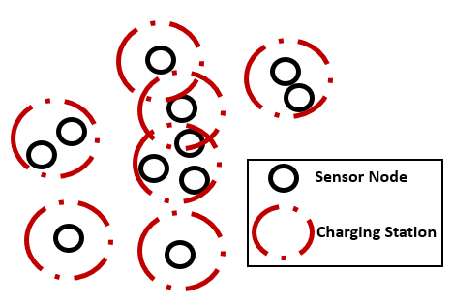Hybrid Particle Swarm Optimization Genetic Algorithm (HPSOGA) is proposed.

Figure 2. Typical example of indoor environment

A typical example of indoor environment is shown in Figure 1. In indoor environment, how to deploy the charging station is an important topic. The charging station deployment needs to consider the sensor node position, radio frequency interference, charging efficiency, etc. A good charging stations deployment intend to minimize the number of deployed charging station under the requirement of covering all sensor nodes. Jian *et al.* [11] proposed a movable-charger-based algorithm (MCBA), by using overlapping area of charging antenna covered area to ﬁnd out some candidate locations which can deploy charging stations then record them to a set and use greedy algorithm to solve. Chien *et al.* [12] used the candidate set after MCBA and proposed a simulated anneal (SA) algorithm to find the final charging station locations. [13] used the layoff algorithm to improve the elimination of unnecessary solutions during SA iterations to save computation time.

Although previous methods do reduce the number of charging stations, they do not consider the charging efficiency of each sensor node under the same coverage of charging station. Actually, when the distance between sensor node and charging station decreases, the charging efficiency will be increased. Consequently, the charging stations do not need to replenish the sensor nodes’ power frequently. Therefore, this paper proposes a new deploy strategy by taking the number of charging stations and the distance between sensor node and charging station into account simultaneously. We formulate the proposed strategy into a multi-objective problem and employ a non-dominated sorting genetic algorithm-II (NSGA-II) [14] to solve this problem.

1.2 Contributions

The main contributions of this dissertation are listed as follows:

1. Both the number of charging station and the distance between the charging station and the sensor node were considered in a WRSN
2. We formulate the proposed strategy into a multi-objective problem
3. A NSGA-II algorithm is proposed to solve a charging station deployment problem
4. A new NSGA-II chromosome coding is provided to problem formulation
5. NSGA-II parameter-settings were discussed in a convergence experiment

The remaining portion of this paper is organized as follows. Recent related studies are discussed in chapter 2. Chapter 3 describes the system model and presents the problem formulation. The NSGA-II charging station deployment algorithm is introduced in chapter 4. In chapter 5, we conduct a simulation to verify the applicability of proposed approach and compare it with other prominent methods. Finally, the conclusions are provided in chapter 6.